**Lab 03**

**21k-3881**

**BY SWING:**

**Task01**

import javax.swing.*;  
import java.awt.*;  
import java.awt.event.*;  
public class t1{  
 public static void main(String[] args){  
 JFrame f=new JFrame();  
 Container con=f.getContentPane();  
 con.setLayout(null);  
 JLabel n1=new JLabel("NAME ");  
 n1.setBounds(110, 90, 210, 30);  
 con.add(n1);  
 JTextField txn=new JTextField();  
 txn.setBounds(170, 90, 210, 30);  
 con.add(txn);  
 JLabel a1=new JLabel("ADDRESS");  
 a1.setBounds(110, 120, 210, 30);  
 con.add(a1);  
 JTextField txa=new JTextField();  
 txa.setBounds(170, 120, 210, 30);  
 con.add(txa);  
 JLabel p1=new JLabel("PHONE ");  
 p1.setBounds(110, 150, 210, 30);  
 con.add(p1);  
 JTextField txp=new JTextField();  
 txp.setBounds(170, 150, 210, 30);  
 con.add(txp);  
 f.setTitle("Address Book");  
 f.setBounds(9, 9, 400, 300);  
 f.setVisible(true);  
 JButton b=new JButton("SUBMIT");  
 b.setBounds(170, 180, 210, 30);  
 con.add(b);  
 JLabel na,ad,ph;  
 na=new JLabel();  
 na.setBounds(170, 240, 210, 30);  
 con.add(na);  
 ad=new JLabel();  
 ad.setBounds(170, 270, 210, 30);  
 con.add(ad);  
 ph=new JLabel();  
 ph.setBounds(170, 300, 210, 30);  
 con.add(ph);  
 b.addActionListener(new ActionListener(){  
 public void actionPerformed(ActionEvent ae){  
 String n=txn.getText();  
 String a=txa.getText();  
 String p=txp.getText();  
 if(!n.equals("")&&!a.equals("")&&!p.equals("") ){  
 if(ae.getSource()==b){  
 na.setText("NAME = "+txn.getText());  
 ad.setText("ADDRESS = "+txa.getText());  
 ph.setText("PHONE = "+txp.getText());  
 } }  
 }  
 });  
 } }

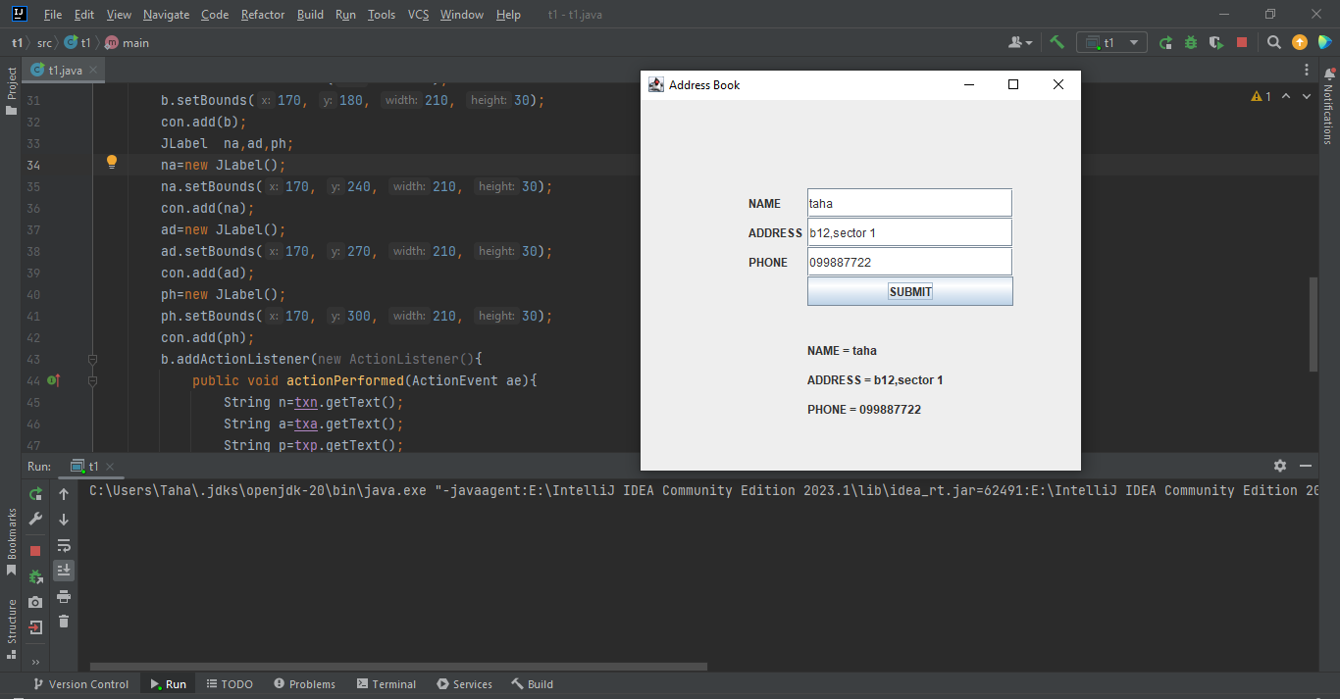

**Task 02**

import javax.swing.*;  
import java.awt.*;  
import java.awt.event.*;  
class frame extends JFrame implements ActionListener{  
 JTextField txn,txa,txe;  
 JLabel v;  
 JButton b;  
 frame(){  
 setTitle("Student Registration Form");  
 setBounds(9, 9, 400, 300);  
 Container con=getContentPane();  
 con.setLayout(null);  
 JLabel n=new JLabel("NAME");  
 n.setBounds(110, 90, 210, 30);  
 con.add(n);  
 txn=new JTextField();  
 txn.setBounds(170, 90, 210, 30);  
 con.add(txn);  
 JLabel a=new JLabel("AGE");  
 a.setBounds(110, 120, 210, 30);  
 con.add(a);  
 txa=new JTextField();  
 txa.setBounds(170, 120, 210, 30);  
 con.add(txa);  
 JLabel e=new JLabel("EMAIL");  
 e.setBounds(110, 150, 210, 30);  
 con.add(e);  
 txe=new JTextField();  
 txe.setBounds(170, 150, 210, 30);  
 con.add(txe);  
 b=new JButton("SUBMIT");  
 b.setBounds(170, 180, 210, 30);  
 con.add(b);  
 v=new JLabel();  
 v.setBounds(170, 210, 210, 30);  
 con.add(v);  
 b.addActionListener(this);  
 setVisible(true);  
 }  
 public void actionPerformed(ActionEvent e){  
 String n=txn.getText();  
 String ag=txa.getText();  
 String em=txe.getText();  
 if(!n.equals("")&&!ag.equals("")&&!em.equals("")){  
 if(e.getSource()==b){  
 txn.setText(" ");  
 txa.setText(" ");  
 txe.setText(" ");  
 v.setText("REGISTERED SUCCESSFULLY!!!");  
 } }  
 } }  
public class t2 {  
 public static void main(String[] args) {  
 frame fra=new frame();  
 } }

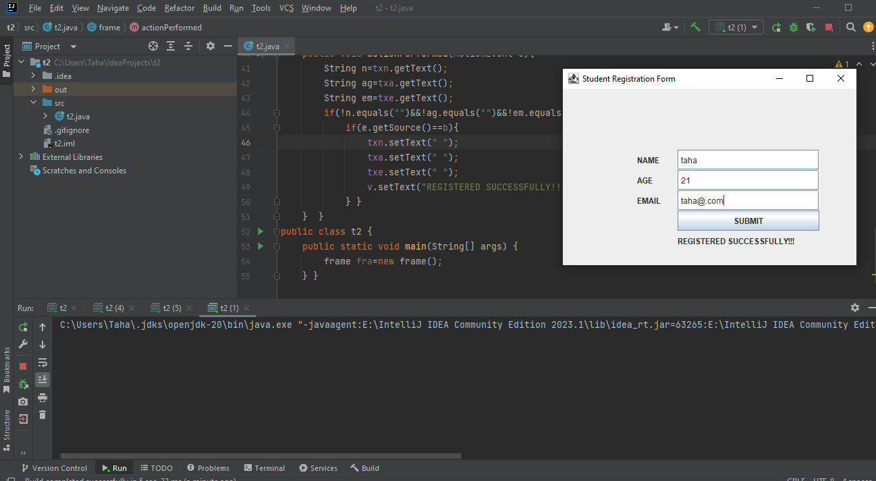

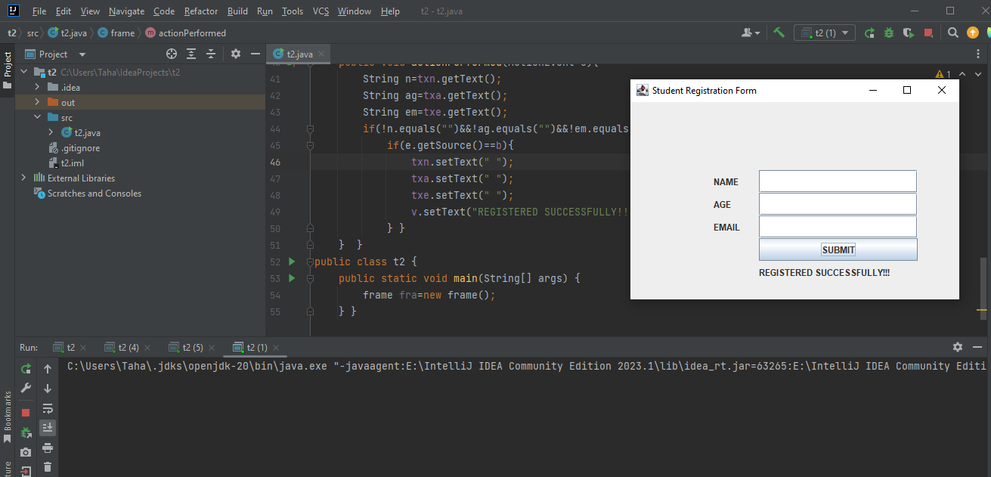

**TASK 03**

import javax.swing.*;  
import java.awt.*;  
import java.awt.event.ActionListener;  
import java.awt.event.ActionEvent;  
  
public class t3 implements ActionListener{  
 JTextField txt;  
 JFrame f;  
  
 JButton[] bt=new JButton[10];  
 JButton[] btn=new JButton[7];  
 JButton a,s,m,d,de,eq;  
 JPanel p;  
 Font fn=new Font("Yellow",Font.*BOLD*,23);  
 char op;  
 double n1=0,m1=0,v=0;  
 public t3(){  
 f= new JFrame("SIMPLE CALCULATOR");  
 f.setSize(350,500);  
 f.setLayout(null);  
 txt=new JTextField();  
 txt.setBounds(60, 35, 310, 60);  
 txt.setFont(fn);  
 txt.setEditable(false);  
 a=new JButton("+");  
 s=new JButton("-");  
 m=new JButton("*");  
 d=new JButton("/");  
 de=new JButton(".");  
 eq=new JButton("=");  
 btn[0]=a;  
 btn[1]=s;  
 btn[2]=m;  
 btn[3]=d;  
 btn[4]=de;  
 btn[5]=eq;  
 //btn[6]=c;  
 btn[0].addActionListener(this);  
 btn[0].setFont(fn);  
 btn[1].addActionListener(this);  
 btn[1].setFont(fn);  
 btn[2].addActionListener(this);  
 btn[2].setFont(fn);  
 btn[3].addActionListener(this);  
 btn[3].setFont(fn);  
 btn[4].addActionListener(this);  
 btn[4].setFont(fn);  
 btn[5].addActionListener(this);  
 btn[5].setFont(fn);  
 bt[0]=new JButton(String.*valueOf*(0));  
 bt[0].addActionListener(this);  
 bt[0].setFont(fn);  
 bt[1]=new JButton(String.*valueOf*(1));  
 bt[1].addActionListener(this);  
 bt[1].setFont(fn);  
 bt[2]=new JButton(String.*valueOf*(2));  
 bt[2].addActionListener(this);  
 bt[2].setFont(fn);  
 bt[3]=new JButton(String.*valueOf*(3));  
 bt[3].addActionListener(this);  
 bt[3].setFont(fn);  
 bt[4]=new JButton(String.*valueOf*(4));  
 bt[4].addActionListener(this);  
 bt[4].setFont(fn);  
 bt[5]=new JButton(String.*valueOf*(5));  
 bt[5].addActionListener(this);  
 bt[5].setFont(fn);  
 bt[6]=new JButton(String.*valueOf*(6));  
 bt[6].addActionListener(this);  
 bt[6].setFont(fn);  
 bt[7]=new JButton(String.*valueOf*(7));  
 bt[7].addActionListener(this);  
 bt[7].setFont(fn);  
 bt[8]=new JButton(String.*valueOf*(8));  
 bt[8].addActionListener(this);  
 bt[8].setFont(fn);  
 bt[9]=new JButton(String.*valueOf*(9));  
 bt[9].addActionListener(this);  
 bt[9].setFont(fn);  
 //c.setBounds(130,440,160,60);  
 p=new JPanel();  
 p.setBounds(60, 110, 310, 310);  
 p.setLayout(new GridLayout(4,4,5,5));  
 p.add(bt[1]);  
 p.add(bt[2]);  
 p.add(bt[3]);  
 p.add(a);  
 p.add(bt[4]);  
 p.add(bt[5]);  
 p.add(bt[6]);  
 p.add(s);  
 p.add(bt[7]);  
 p.add(bt[8]);  
 p.add(bt[9]);  
 p.add(m);  
 p.add(de);  
 p.add(bt[0]);  
 p.add(eq);  
 p.add(d);  
 f.add(p);  
 f.add(txt);  
 f.setVisible(true); }  
 public static void main(String[] args){  
 t3 d=new t3(); }  
 @Override  
 public void actionPerformed(ActionEvent ae){  
 for(int x=0;x<10;x++){  
 if(ae.getSource()==bt[x]){  
 txt.setText(txt.getText().concat(String.*valueOf*(x))); } }  
 if(ae.getSource()==de){  
 txt.setText(txt.getText().concat(".")); }  
 if(ae.getSource()==a){  
 n1=Double.*parseDouble*(txt.getText());  
 op='+';  
 txt.setText("+"); }  
 if(ae.getSource()==s){  
 n1=Double.*parseDouble*(txt.getText());  
 op='-';  
 txt.setText("-"); }  
 if(ae.getSource()==m){  
 n1=Double.*parseDouble*(txt.getText());  
 op='*';  
 txt.setText("*"); }  
 if(ae.getSource()==d){  
 n1=Double.*parseDouble*(txt.getText());  
 op='/';  
 txt.setText("/"); }  
 if(ae.getSource()==eq){  
 m1=Double.*parseDouble*(txt.getText());  
 switch (op){  
 case '+' -> v=n1+m1;  
 case '-' -> v=n1-m1;  
 case '*' -> v=n1*m1;  
 case '/' -> v=n1/m1; }  
 txt.setText(String.*valueOf*(v));  
 n1=v; }  
 } }

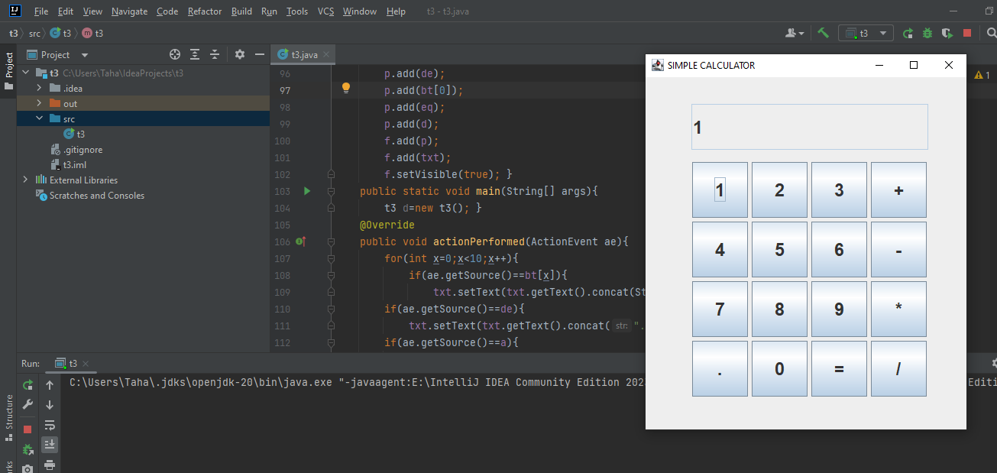

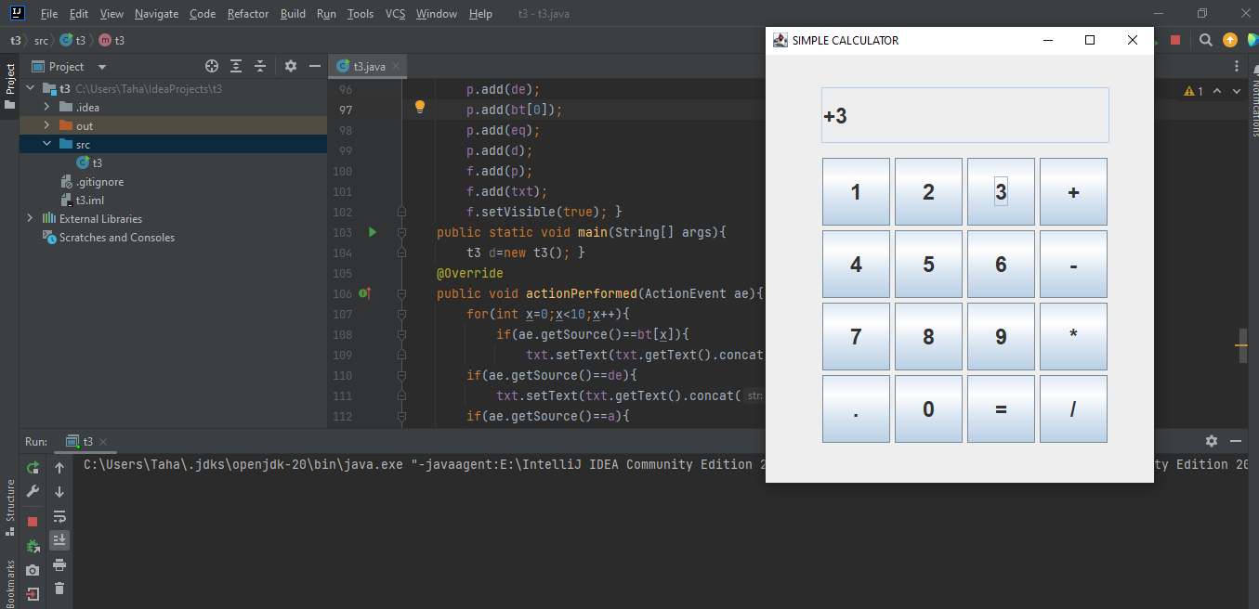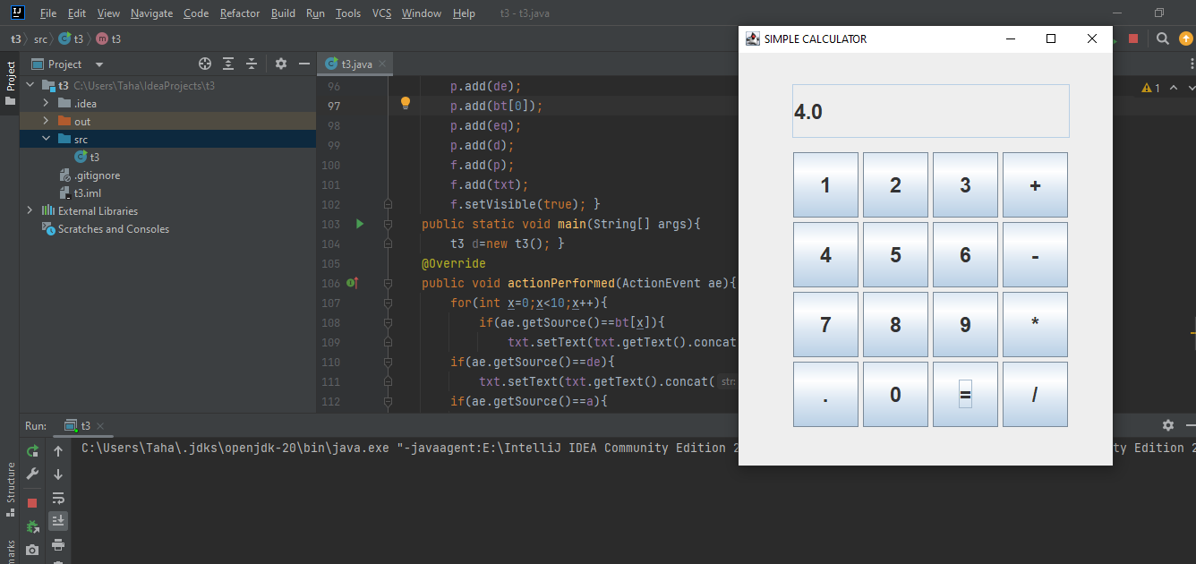

**Tasks By JAVA FX**

**Task 01**

package com.example.t1;  
import javafx.application.Application;  
import javafx.event.*;  
import javafx.scene.*;  
import javafx.scene.Group;  
import javafx.scene.Scene;  
import javafx.scene.control.*;  
import javafx.scene.effect.*;  
import javafx.scene.layout.*;  
import javafx.stage.Stage;  
import javafx.scene.image.*;  
import javafx.scene.input.KeyCombination;  
import javafx.scene.paint.Color;  
import javafx.scene.text.*;  
public class t1 extends Application{  
 @Override  
 public void start(Stage ps) {  
 HBox p=new HBox();  
 HBox q=new HBox();  
 HBox r=new HBox();  
 VBox pa=new VBox();  
 Label n=new Label("NAME");  
 Label ph=new Label("PHONE");  
 Label a=new Label("ADDRESS");  
 TextField txn=new TextField();  
 txn.setMaxWidth(230);  
 TextField txp=new TextField();  
 txp.setMaxWidth(230);  
 TextField txa=new TextField();  
 txa.setMaxWidth(230);  
 Label n1=new Label(" ");  
 Label a1=new Label(" ");  
 Label p1=new Label(" ");  
 Button b=new Button("SUBMIT");  
 b.setMaxWidth(200);  
 pa.setSpacing(10);  
 p.getChildren().add(txn);  
 p.getChildren().add(n1);  
 p.setSpacing(10);  
 q.getChildren().add(txp);  
 q.getChildren().add(p1);  
 q.setSpacing(10);  
 r.getChildren().add(txa);  
 r.getChildren().add(a1);  
 r.setSpacing(10);  
 pa.getChildren().add(n);  
 pa.getChildren().add(p);  
 pa.getChildren().add(ph);  
 pa.getChildren().add(q);  
 pa.getChildren().add(a);  
 pa.getChildren().add(r);  
 pa.getChildren().add(b);  
 Label re=new Label();  
 Label la=new Label();  
 Label lb=new Label();  
 Label lc=new Label();  
 pa.getChildren().add(re);  
 pa.getChildren().add(la);  
 pa.getChildren().add(lb);  
 pa.getChildren().add(lc);  
 b.setOnAction(new EventHandler<ActionEvent>(){  
 public void handle(ActionEvent ae){  
 String n=txn.getText();  
 String p=txp.getText();  
 String a=txa.getText();  
 if(ae.getSource()==b){  
 if(!n.equals("")){  
 n1.setText(""); }  
 if(!p.equals("")) {  
 p1.setText(""); }  
 if(!a.equals("")) {  
 a1.setText(""); }  
 if(!n.equals("")&&!p.equals("")&&!a.equals("")){  
 la.setText("NAME = "+n);  
 lb.setText("PHONE = "+p);  
 lc.setText("ADDRESS = "+a);  
 txn.setText("");  
 txp.setText("");  
 txa.setText("");  
 }  
 }  
 if(ae.getSource()==b){  
 if(n.equals("")){  
 n1.setText("name not filled"); }  
 else if(p.equals("")){  
 p1.setText("phone no not filled"); }  
 else if(a.equals("")){  
 a1.setText("address not filled"); }  
 } }  
 });  
 Scene sc=new Scene(pa);  
 ps.setScene(sc);  
 ps.setTitle("ADDRESS BOOK");  
 ps.setWidth(510);  
 ps.setHeight(610);  
 ps.show();}  
 public static void main(String[] args) {  
 *launch*(args);  
 }

}

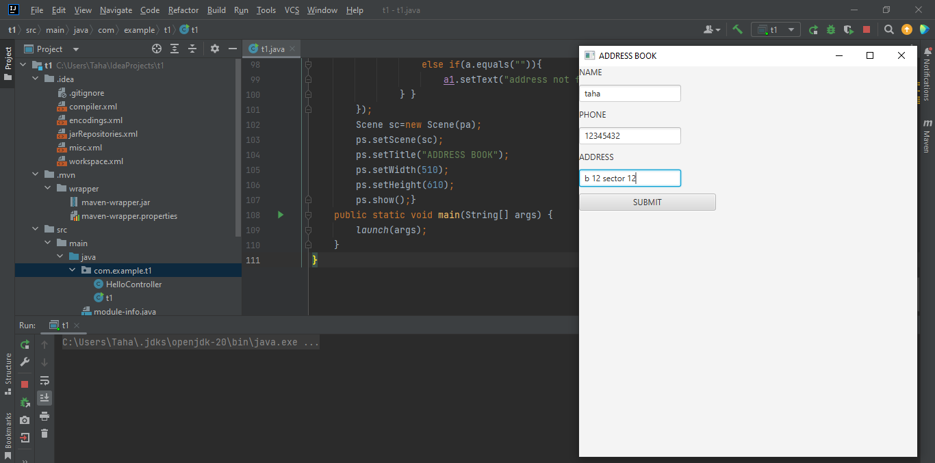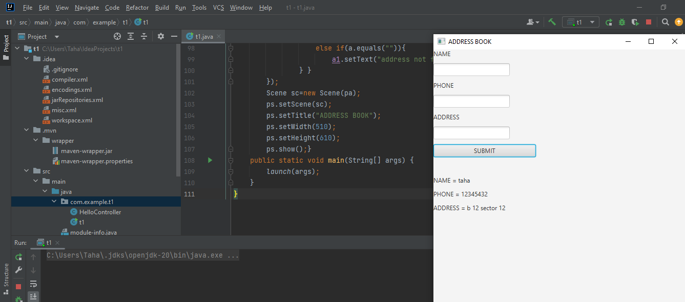

**Task 02**

package com.example.ta2;  
import javafx.application.Application;  
import javafx.event.ActionEvent;  
import javafx.event.EventHandler;  
import javafx.scene.Scene;  
import javafx.scene.control.Button;  
import javafx.scene.control.Label;  
import javafx.scene.control.TextField;  
import javafx.scene.layout.HBox;  
import javafx.scene.layout.StackPane;  
import javafx.scene.layout.VBox;  
import javafx.scene.text.Font;  
import javafx.scene.text.FontWeight;  
import javafx.stage.Stage;  
public class ta2 extends Application{  
 @Override  
 public void start(Stage ps){  
 HBox p=new HBox();  
 HBox q=new HBox();  
 HBox r=new HBox();  
 HBox s=new HBox();  
 VBox pa=new VBox();  
 Label n=new Label("NAME ");  
 Label a=new Label("AGE ");  
 Label e=new Label("EMAIL");  
 TextField txn=new TextField();  
 txn.setMaxWidth(230);  
 TextField txa=new TextField();  
 txa.setMaxWidth(230);  
 TextField txe=new TextField();  
 txe.setMaxWidth(230);  
 Label n1=new Label(" ");  
 Label a1=new Label(" ");  
 Label e1=new Label(" ");  
 Button b=new Button("REGISTER");  
 b.setMaxWidth(200);  
 pa.setSpacing(10);  
 p.getChildren().add(n);  
 p.getChildren().add(txn);  
 p.getChildren().add(n1);  
 p.setSpacing(10);  
 q.getChildren().add(a);  
 q.getChildren().add(txa);  
 q.getChildren().add(a1);  
 q.setSpacing(10);  
 r.getChildren().add(e);  
 r.getChildren().add(txe);  
 r.getChildren().add(e1);  
 r.setSpacing(10);  
 s.getChildren().add(b);  
 pa.getChildren().add(p);  
 pa.getChildren().add(q);  
 pa.getChildren().add(r);  
 pa.getChildren().add(s);  
 pa.setSpacing(20);  
 Label l=new Label();  
 pa.getChildren().add(l);  
 b.setOnAction(new EventHandler<ActionEvent>(){  
 public void handle(ActionEvent ae) {  
 String n=txn.getText();  
 String p=txa.getText();  
 String a=txe.getText();  
 if(ae.getSource()==b){  
 if(!n.equals("")){  
 n1.setText(""); }  
 if(!p.equals("")) {  
 e1.setText(""); }  
 if(!a.equals("")){  
 a1.setText(""); }  
 if(!n.equals("")&&!p.equals("")&&!a.equals("")){  
 l.setText("REGISTERED SUCESSFULLY!!!");  
 txn.setText("");  
 txe.setText("");  
 txa.setText("");  
 } }  
 if(ae.getSource()==b){  
 if(n.equals("")){  
 n1.setText("name is null"); }  
 else if(p.equals("")){  
 a1.setText("age is null"); }  
 else if(a.equals("")){  
 e1.setText("email is null"); }  
 } }  
 });  
 Scene sc=new Scene(pa);  
 ps.setScene(sc);  
 ps.setTitle("STUDENT REGISTRATION FORM");  
 ps.setWidth(600);  
 ps.setHeight(400);  
 ps.show(); }  
 public static void main(String[] args) {  
 *launch*(args); }  
}

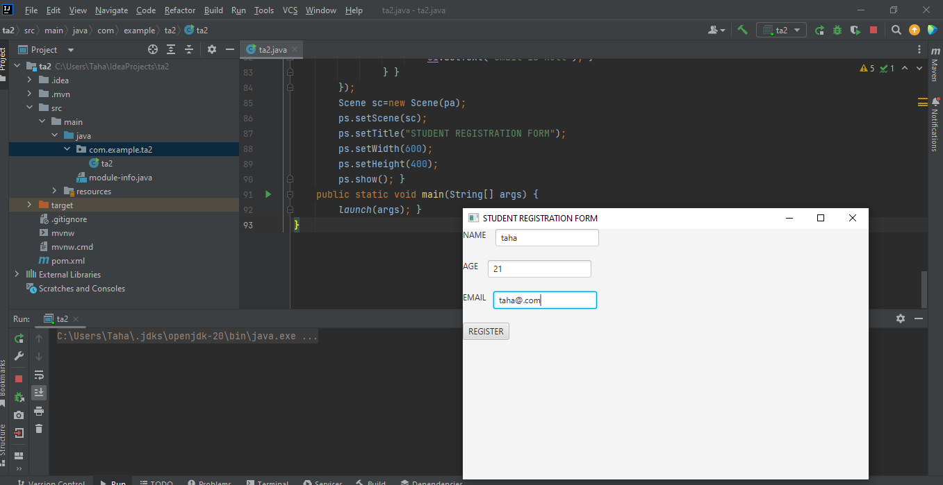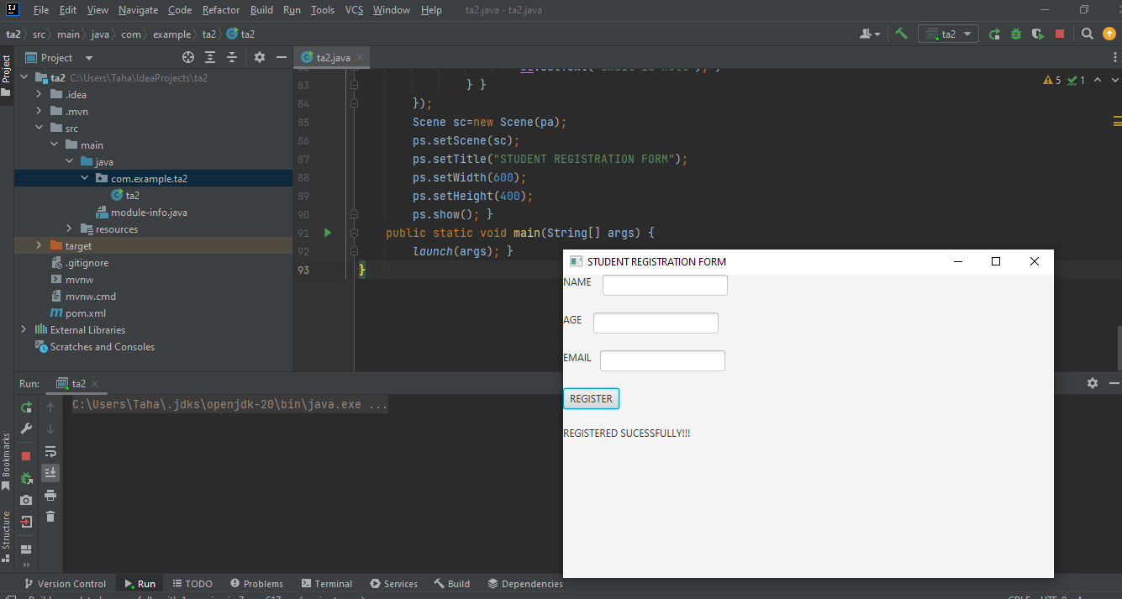

**Task 03**

package com.example.t3;  
import javafx.application.Application;  
import javafx.event.ActionEvent;  
import javafx.event.EventHandler;  
import javafx.scene.*;  
import javafx.scene.Group;  
import javafx.scene.Scene;  
import javafx.scene.control.*;  
import javafx.scene.effect.*;  
import javafx.scene.layout.*;  
import javafx.stage.Stage;  
import javafx.scene.image.*;  
import javafx.scene.input.KeyCombination;  
import javafx.scene.paint.Color;  
import javafx.scene.text.*;  
public class t3 extends Application implements EventHandler<ActionEvent>{  
 @Override  
 public void start(Stage ps){  
 ps.setTitle("SIMPLE CALCULATOR");  
 HBox a=new HBox();  
 HBox b=new HBox();  
 HBox c=new HBox();  
 HBox d=new HBox();  
 HBox e=new HBox();  
 HBox f=new HBox();  
 HBox g=new HBox();  
 VBox av=new VBox();  
 l=new Label("");  
 la = new Label("");  
 lb=new Label("");  
 lc=new Label("");  
 b1=new Button("7");  
 b1.setOnAction(this);  
 b2=new Button("8");  
 b2.setOnAction(this);  
 b3=new Button("9");  
 b3.setOnAction(this);  
 b4=new Button("*");  
 b4.setOnAction(this);  
 b5=new Button("4");  
 b5.setOnAction(this);  
 b6=new Button("5");  
 b6.setOnAction(this);  
 b7=new Button("6");  
 b7.setOnAction(this);  
 b8=new Button("/");  
 b8.setOnAction(this);  
 b9=new Button("1");  
 b9.setOnAction(this);  
 b10=new Button("2");  
 b10.setOnAction(this);  
 b11=new Button("3");  
 b11.setOnAction(this);  
 b12=new Button("+");  
 b12.setOnAction(this);  
 b13=new Button("0");  
 b13.setOnAction(this);  
 b14=new Button("-");  
 b14.setOnAction(this);  
 b15=new Button("=");  
 b15.setOnAction(this);  
 b16=new Button("C");  
 b16.setOnAction(this);  
 b.getChildren().add(l);  
 b.getChildren().add(la);  
 b.getChildren().add(lb);  
 c.getChildren().add(lc);  
 d.getChildren().add(b1);  
 d.getChildren().add(b2);  
 d.getChildren().add(b3);  
 d.getChildren().add(b16);  
 d.setSpacing(25);  
 e.getChildren().add(b5);  
 e.getChildren().add(b6);  
 e.getChildren().add(b7);  
 e.getChildren().add(b4);  
 e.setSpacing(25);  
 f.getChildren().add(b9);  
 f.getChildren().add(b10);  
 f.getChildren().add(b11);  
 f.getChildren().add(b8);  
 f.setSpacing(25);  
 g.getChildren().add(b13);  
 g.getChildren().add(b14);  
 g.getChildren().add(b12);  
 g.getChildren().add(b15);  
 g.setSpacing(25);  
 av.getChildren().add(a);  
 av.getChildren().add(b);  
 av.getChildren().add(c);  
 av.getChildren().add(d);  
 av.getChildren().add(e);  
 av.getChildren().add(f);  
 av.getChildren().add(g);  
 av.setSpacing(15);  
 Scene sc=new Scene(av);  
 ps.setScene(sc);  
 ps.setWidth(260);  
 ps.setHeight(310);  
 ps.show(); }  
 Label l,la,lb,lc;  
 Button b1,b2,b3,b4;  
 Button b5,b6,b7,b8;  
 Button b9,b10,b11,b12;  
 Button b13,b14,b15,b16;  
 public void handle(ActionEvent ae){  
 String m=b4.getText();  
 String d=b8.getText();  
 String a=b12.getText();  
 String s=b14.getText();  
 String d1=l.getText();  
 String ch=la.getText();  
 String d2=lb.getText();  
 int re;  
 if(ae.getSource()==b3&&d1.equals("")){  
 l.setText("9"); }  
 else if(ae.getSource()==b3&&d2.equals("")){  
 lb.setText("9"); }  
 if(ae.getSource()==b2&&d1.equals("")){  
 l.setText("8"); }  
 else if(ae.getSource()==b2&&d2.equals("")){  
 lb.setText("8"); }  
 if(ae.getSource()==b1&&d1.equals("")){  
 l.setText("7"); }  
 else if(ae.getSource()==b1&&d2.equals("")){  
 lb.setText("7"); }  
 if(ae.getSource()==b7&&d1.equals("")){  
 l.setText("6"); }  
 else if(ae.getSource()==b7&&d2.equals("")){  
 lb.setText("6"); }  
 if(ae.getSource()==b6&&d1.equals("")){  
 l.setText("5"); }  
 else if(ae.getSource()==b6&&d2.equals("")){  
 lb.setText("5"); }  
 if(ae.getSource()==b5&&d1.equals("")){  
 l.setText("4"); }  
 else if(ae.getSource()==b5&&d2.equals("")){  
 lb.setText("4"); }  
 if(ae.getSource()==b11&&d1.equals("")){  
 l.setText("3"); }  
 else if(ae.getSource()==b11&&d2.equals("")){  
 lb.setText("3"); }  
 if(ae.getSource()==b10&&d1.equals("")){  
 l.setText("2"); }  
 else if(ae.getSource()==b10&&d2.equals("")){  
 lb.setText("2"); }  
 if(ae.getSource()==b9&&d1.equals("")){  
 l.setText("1"); }  
 else if(ae.getSource()==b9&&d2.equals("")){  
 lb.setText("1"); }  
 if(ae.getSource()==b13&&d1.equals("")){  
 l.setText("0"); }  
 else if(ae.getSource()==b13&&d2.equals("")){  
 lb.setText("0"); }  
 if(ae.getSource()==b4){  
 la.setText("*"); }  
 if(ae.getSource()==b8){  
 la.setText("/"); }  
 if(ae.getSource()==b12){  
 la.setText("+"); }  
 if(ae.getSource()==b14){  
 la.setText("-"); }  
 try{  
 if(ae.getSource()==b15){  
 int di1=Integer.*parseInt*(l.getText());  
 int di2=Integer.*parseInt*(lb.getText());  
 if(ch.equals("+")){  
 re=di1+di2;  
 String rx=String.*valueOf*(re);  
 lc.setText(rx); }  
 if(ch.equals("-")){  
 re=di1-di2;  
 String rx=String.*valueOf*(re);  
 lc.setText(rx); }  
 if(ch.equals("*")){  
 re=di1*di2;  
 String r1=String.*valueOf*(re);  
 lc.setText(r1); }  
 if(ch.equals("/")){  
 float div1=Float.*parseFloat*(l.getText());  
 float div2=Float.*parseFloat*(lb.getText());  
 float rd=div1/div2;  
 String rx=String.*valueOf*(rd);  
 lc.setText(rx); }  
 }  
 }  
 catch(ArithmeticException e){  
 lc.setText("Infinity"); }  
 if(ae.getSource()==b16){  
 l.setText("");  
 la.setText("");  
 lb.setText("");  
 lc.setText(""); }  
 }  
 public static void main(String[] args) {  
 *launch*(args); }  
}

